Term Project Part 2 Report_Group 2
Presented by Group 2: Davide Cacciuottolo, Lily Lin, Melina Kaelin, Puntharee Manakul, Solveig Ervik, Bui Xuan Phat

1. Keyword research
Before we move forward, we want to recap our target audience and focus on who this project is meant for. We believe this tool would work best for small businesses, such as mom-and-pop shops, local coffee shops, and small specialty shops. Additionally because of our tool is social media focus so the niche we want to focus on within is digital marketing They won’t have the foundational knowledge to approach marketing but still have general awareness that they need to leverage social media marketing for their business. They are completely brand new for social media marketing, and they don’t even know where to start.

Criteria:
Demand: the demand for our audience(small business/ mom and pop shop) to search for this keyword
Fit: how the keyword fits the small business use case (in this scenario, it is for small businesses to have customers know their business exists via social media)
Intent: What is the audience intent
Difficulty: The competitive bidding in the keyword search is in a fair range

We use this main keyword: best social media platforms for businesses (in the url)
Because:
- Highly relevant to the target audience
- Has a decent difficulty score of 40
- Has a decent search volume per month of 650 per month
- Has a low SERF feature count on that term (So it is easier to show on top pages)
- Has a high potential for in-depth content and utilizing the skyscraper method
And the following sub keyword: social media content creation

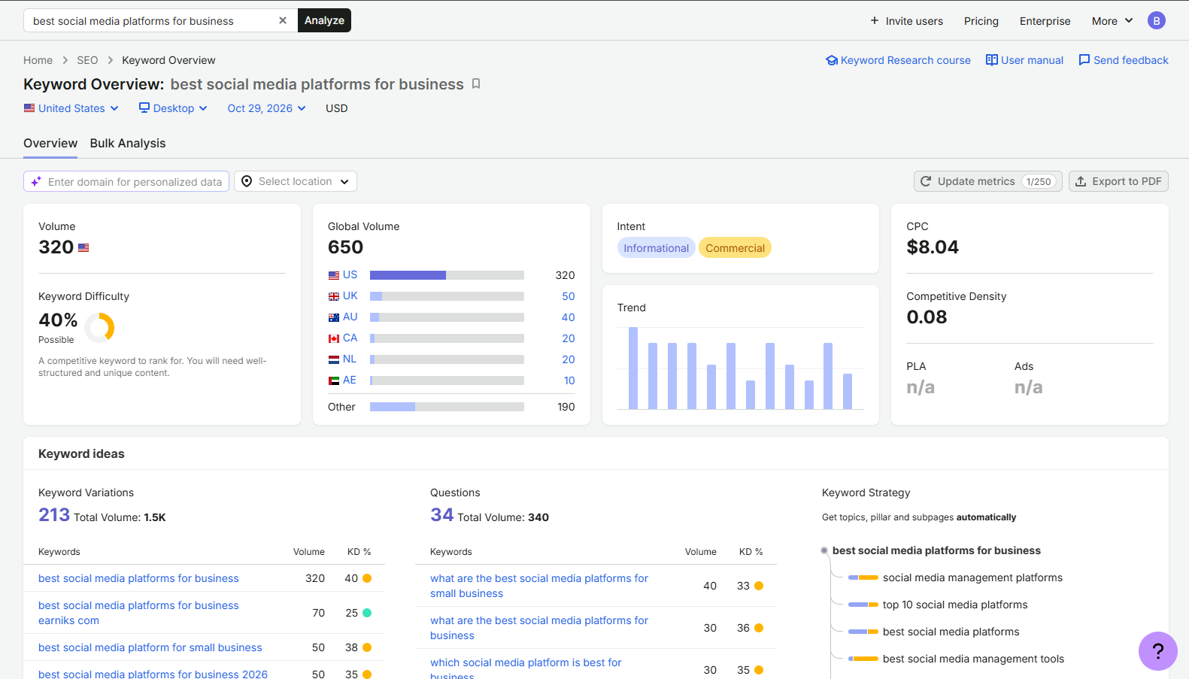

The steps that we took to reach this keyword
Using Semrush: we searched for the service that our website provides, which is social media strategy. With a filter volume range from 500 - 100,000
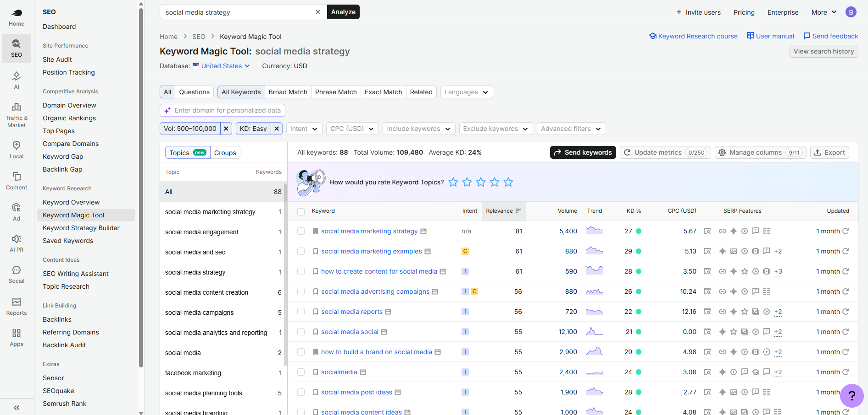

After choosing a bunch of keywords, we moved on to our competitors and used the SemRush Keyword Gap tool to find which keywords that our competitors are not using.

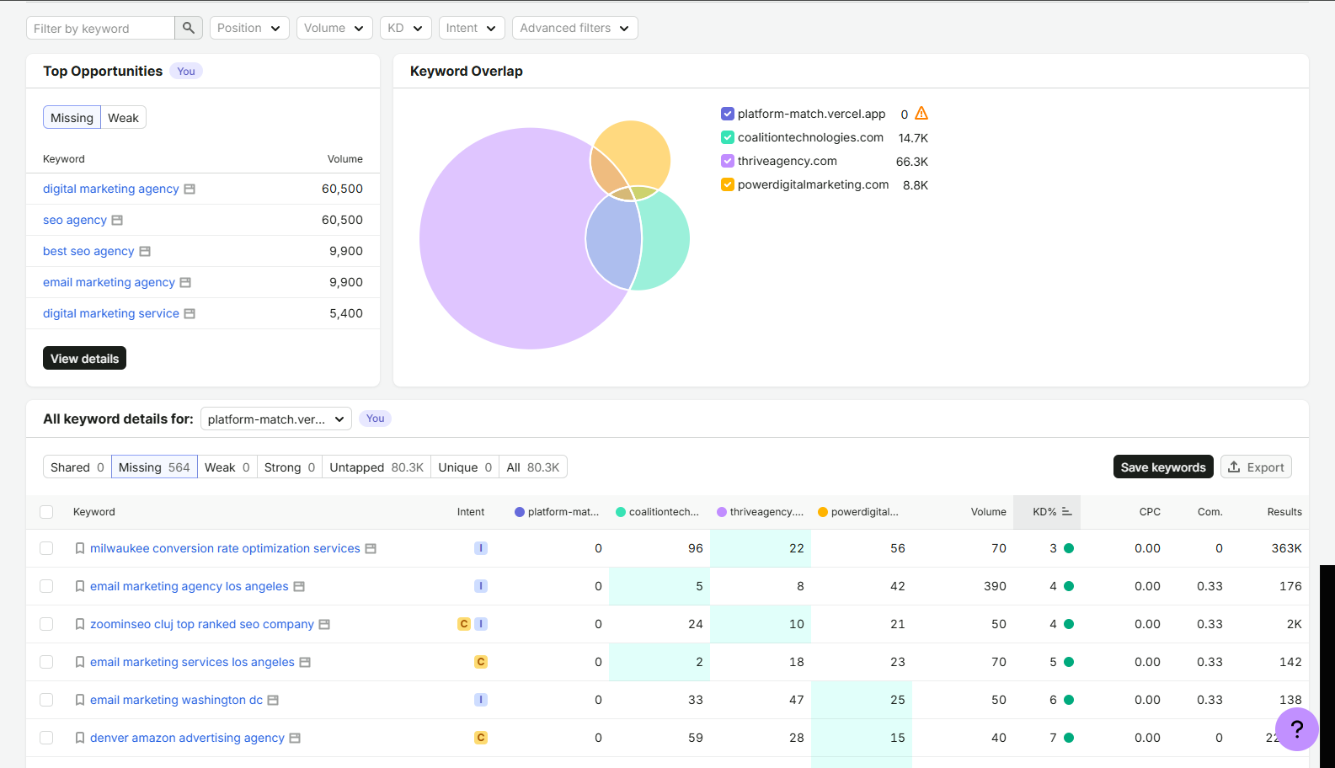

After we have compiled a list of keywords, we decided to choose the final option due to it being the greatest fit and highly relevant for both our target audience and the service that we provide. Though we could have chosen a keyword with a lower difficulty score, we believe that our interactive quiz will allow us to have a competitive edge against our competitor, and we believe that it is a worthy trade-off.

2) ON SITE SEO - build the webpage around the selected keyword

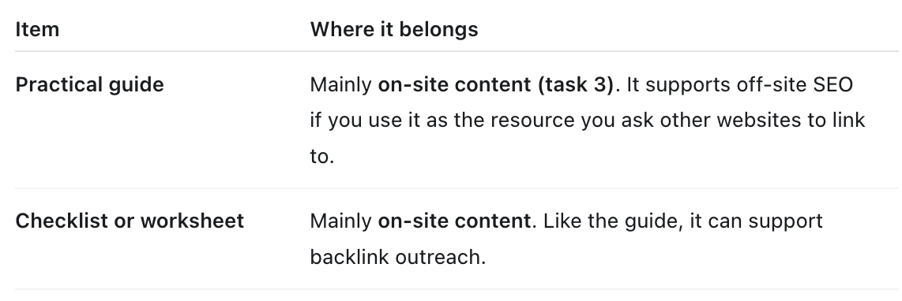
- Clear introduction pages
  - Introduction Page
  - About Us Page
  - Why Choose Us
- Topical Authority Content:
  - Best social media platforms for business
    - Mistakes a business owner made when choosing a social media platform
    - Business owner guide to social media content creation

- Useful guide or worksheet On-site content (supports our backlink strategy)
  - Social media checklist for your business
  - Business owner guide to social media

—
Here is Section 3 rewritten to match the exact tone, structure, and writing style of your team's Keyword Research section (direct, concise, bulleted, with clear criteria, tool callouts, and step-by-step reasoning):

2) ON SITE SEO - build the webpage around the selected keyword
So for on-site SEO, we build a site around this keyword meant for small business owners brand new to digital marketing, and we also modified the way we present the content a bit for AEO as well.
We optimized our webpage using these specific on-site elements:
- URL: https://platform-match.vercel.app/best-social-media-platforms-for-business](https://platform-match.vercel.app/best-social-media-platforms-for-business) Short, clean, and includes the exact target keyword. (DAVIDE)
- Title Tag: <title> Best Social Media Platforms for Business | Platform Match</title> — Places our targeted keyword right at the beginning.
- Meta Description: <meta name="description" content=" Discover the best social media platforms for business in 2026. Use our free decision quiz to compare Instagram, TikTok, Facebook, LinkedIn, YouTube, and Pinterest based on your audience and capacity."> — Written to improve SERP click-through rate.
- H1 Tag: <h1>Find the Best Social Media Platform for Your Business</h1> — Uses the primary keyword in the main page headline.
- H2 Tags: Subheadings structured around secondary search intent, such as <h2>How Your Goals Help You Choose the Best Social Media Platform for Business</h2> and <h2>Choosing the Best Social Media Platform for Business With Limited Time</h2>.
- Image Alt Text: <img src="best-platforms-matrix.png" alt="Comparison chart of the best social media platforms for business"> — Helps search engines read visual content.
The steps that we took to build and optimize this webpage:
- HTML Architecture & Keyword Placement: We placed the target keyword in the first 150 words of the body text and integrated natural variations throughout the copy to avoid keyword stuffing.
- Topical Content Integration (Skyscraper Method): We embedded our practical guide ("How to Choose a Social Media Platform With Limited Time") along with a ready-to-fill planning worksheet directly on the page.
- Internal Linking Strategy: We added contextual internal links using descriptive anchor text (e.g., linking directly from the guide to the interactive quiz.
- Structured Data & Scannability: We added structured weekly schedule tables (breaking down a 3-hour social media workflow) and an FAQ section to boost both dwell time and AI search visibility.
SEO optimized site content: https://docs.google.com/document/d/1X57-_5_Wj86zgGOl6dW68p2bfRyQ5MlM/edit?usp=sharing&ouid=107152796185214192978&rtpof=true&sd=true (DAVIDE)

3) Off Site SEO
Here our goal was it to earn and add relevant links to the free Platform Match tool. This is what we did:
· Skyscraper technique: We prepared a platform-selection guide and planning worksheet to give publishers like https://www.uschamber.com/co/grow/marketing/how-to-choose-social-platforms-for-your-business a useful resource to reference. For Platform Match, that could mean improving an existing guide about choosing social media platforms, adding your worksheet and interactive quiz.
Skyscraper technique: We reviewed the U.S. Chamber of Commerce’s guide, “How to Choose the Best Social Platforms for Your Business.” Our backlink tool reported 14 backlinks from 11 referring domains. We also verified that NoLimit Creatives links to the article.
- Our proposed improvement: Create a practical platform-selection guide with a ready-to-fill worksheet and access to the Platform Match quiz. This would help readers apply the advice to their own business.
- Proposed promotion: Prepare a simulated pitch to NoLimit Creatives explaining how our resource could complement its existing article.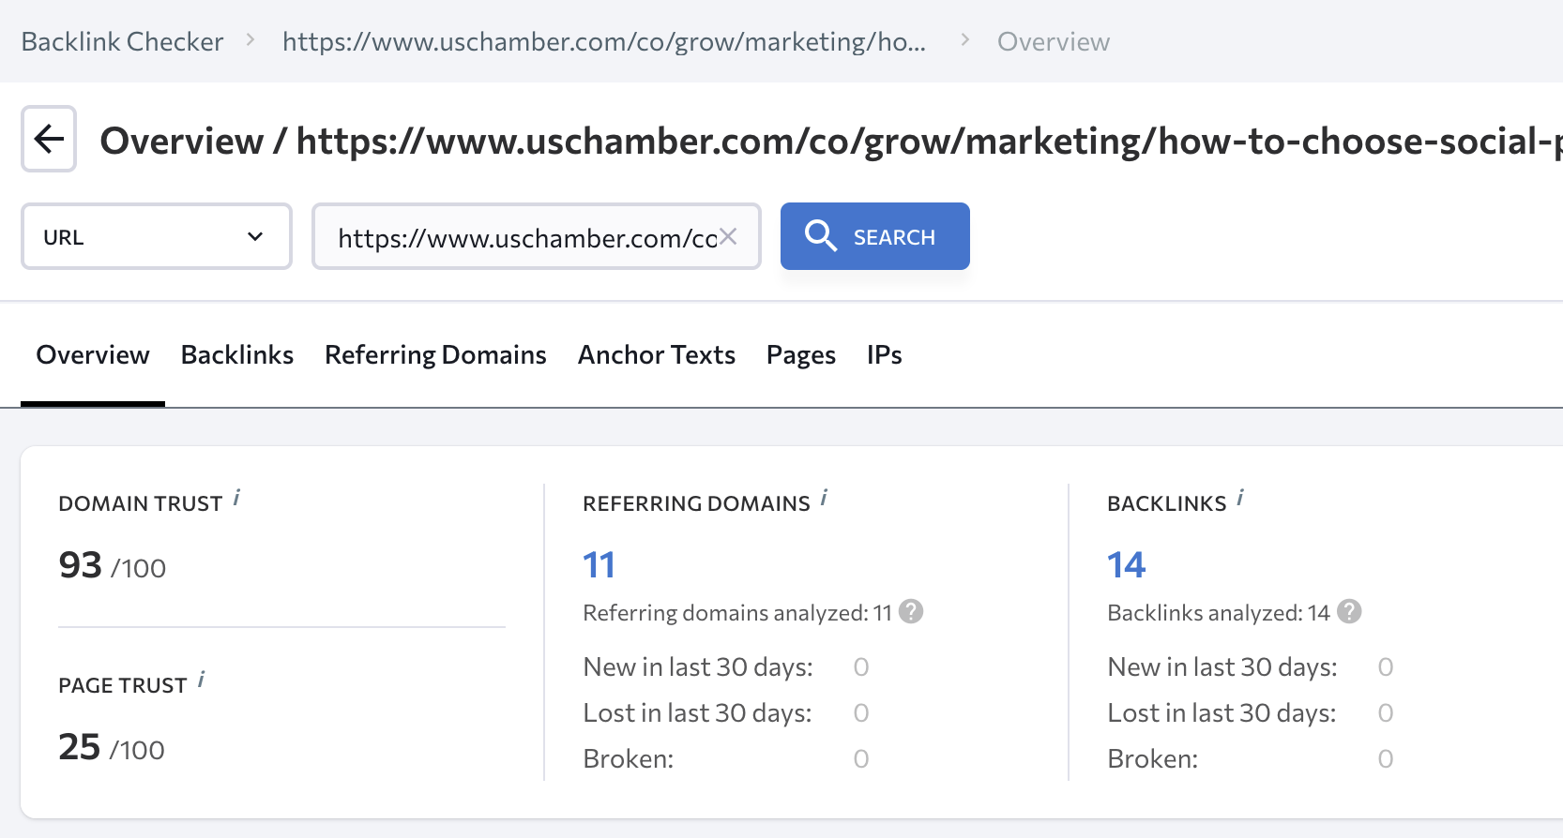

Skyscraper resource for DAVIDE:
- Add a resource page titled “How to Choose a Social Media Platform With Limited Time.” If a separate page is inconvenient, add a resource section to the Platform Match page.
- Include the short guide and planning worksheet already drafted on page 4 of the website changes guide.
- Keep the worksheet readable on the page. A downloadable version is optional.
- Add a button labeled “Try Platform Match” linking to the existing quiz.
- Add a link from the Platform Match overview to the resource, labeled “Read our platform selection guide.”
- Check the page and links on mobile, then publish.
- Capture a screenshot and record the live URL for the report.
Guide:

How to Choose a Social Media Platform With Limited Time
You don’t need to post everywhere. Start by identifying where your customers spend time, what you want to achieve, and what your team can consistently create.

1. Choose one main goal
Decide what social media should help your business achieve: awareness, website visits, inquiries, sales, or community engagement. Choose one priority so you can evaluate whether your efforts are useful.

2. Understand your audience
Describe the people you want to reach. Ask existing customers which platforms they use to discover businesses like yours, or review your website and social media analytics. Use evidence rather than assuming everyone in an age group behaves the same way.

3. Match your content to your capacity
List the formats you can produce confidently, such as photographs, short videos, tutorials, or written posts. Set a realistic weekly time budget that includes creating content, responding to people, and reviewing results.

4. Compare your options
Use Platform Match to explore Instagram, TikTok, Facebook, LinkedIn, YouTube, and Pinterest. Its framework considers audience, marketing goal, industry, content strengths, brand voice, and available time.
Review the recommendation alongside your own customer research. A compatibility score is a planning aid, not a guarantee of results.

5. Start with a manageable plan
Choose one primary channel to test. Set a schedule you can maintain and track an outcome connected to your goal, such as relevant inquiries or website visits. Review what you learn before expanding to another channel.
Ready to compare your options? Try the free Platform Match quiz.
Created by the Platform Match student project team for MAR649.
Further reading: How to Choose the Best Social Platforms for Your Business — U.S. Chamber of Commerce.

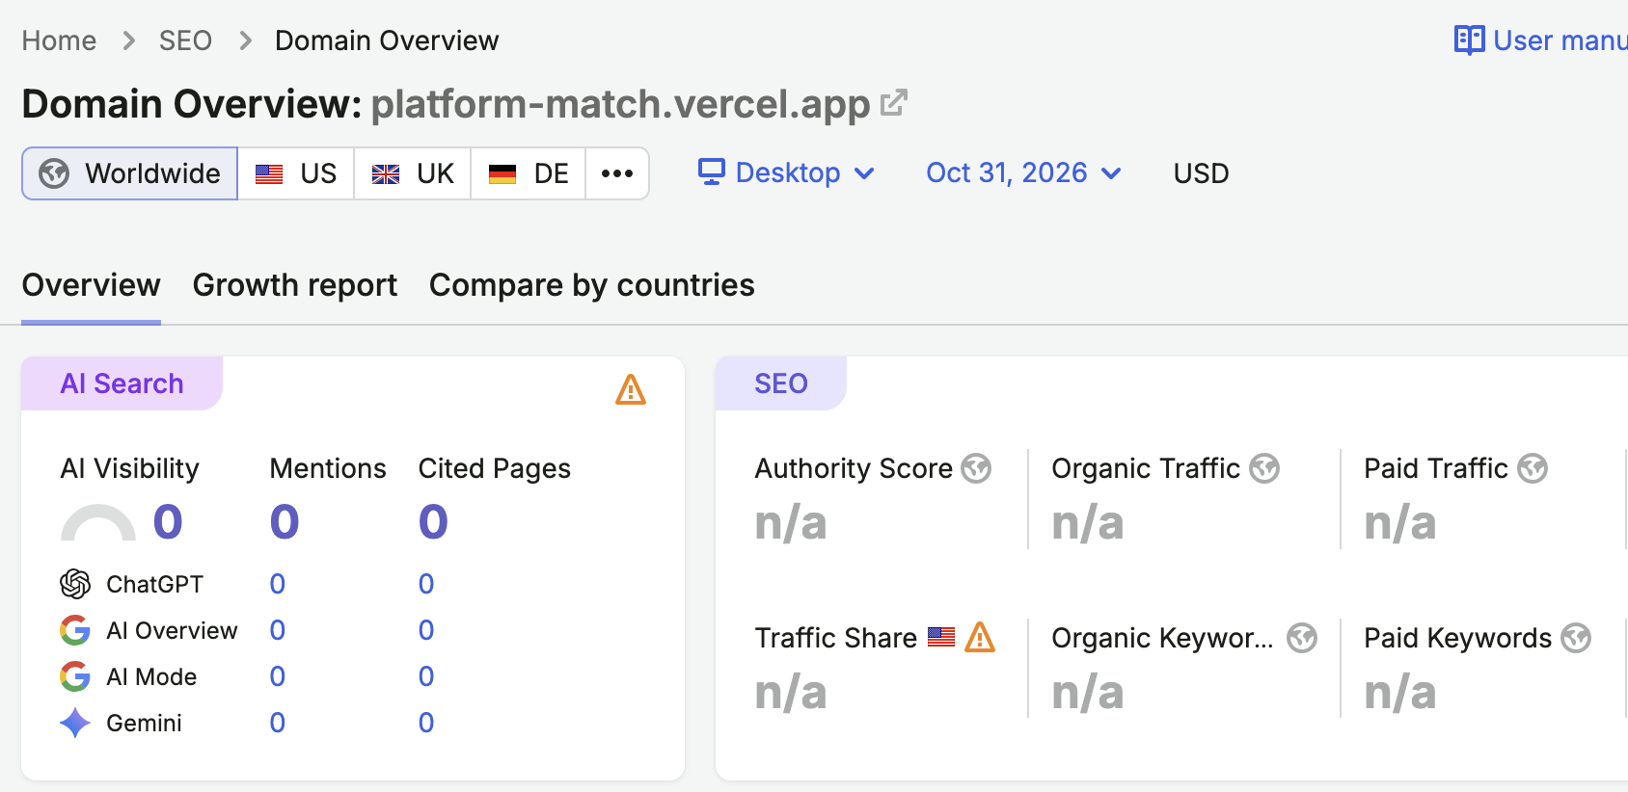

- Backlink partners: we used Semrush to find more websites that link to competitors but don’t link to Platform Match. Those websites, like NoLimit Creatives, Sonary, and Custom Fit Web Design, could become potential backlink targets.
- Resource pages: Selected Pace SBDC (Small Business Development Center) and Brooklyn Public Library business services (supports entrepreneurs and small-business owners and already links to outside support organizations, including Pace SBDC) as potential targets. The idea is to ask the page’s owner to include a link to Platform Match.
- Instagram profile link: Created an Instagram account for Platform Match and added our website link to the bio and connected our social media presence to the website.
- 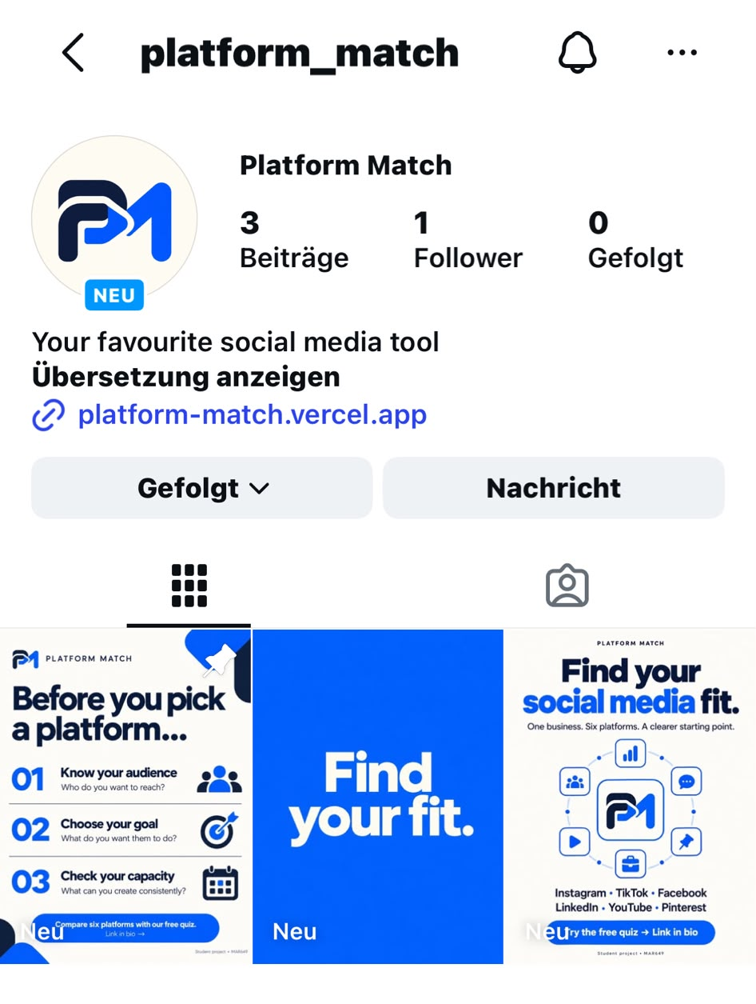to add: screenshot of instalink on website:
- Reporter and blogger contributions: We propose offering a demonstration of Platform Match and an explanation of its decision framework to bloggers covering small-business marketing. If they find it useful, they could mention the tool and link to our website.
Our Email draft:
Hello NoLimit Creatives team, We’re a student group developing Platform Match for a digital marketing course project. Your article about organic social media strategy discusses choosing the right platforms. We could contribute a short demonstration showing how a small business can compare six networks using its audience, goals, content strengths, and available time.
You can explore the tool here:
https://platform-match.vercel.app/platform-match
Would this demonstration be useful as a contribution to your educational content? If you find the tool helpful, we would welcome a mention and link for readers who want to try it.
Thank you,
The Platform Match student project team

Status: campaign materials prepared. No messages sent or backlinks acquired through this work.
[Insert screenshot 1 Resource page prospect]
Show one relevant prospect page. Caption: why its small-business audience fits Platform Match. A prospect is not an acquired link.
[Insert screenshot 2 Sample outreach or competitor research]

4) AEO
Our Goal: make Platform Match clear, credible, and useful as a source in AI-generated answers. Here is what we did:
- SEO foundation: Reviewed the public homepage and tool page. Planned links between the tool, methodology, and supporting guide; keyword and on-site settings like we saw in the previous chapters.
- 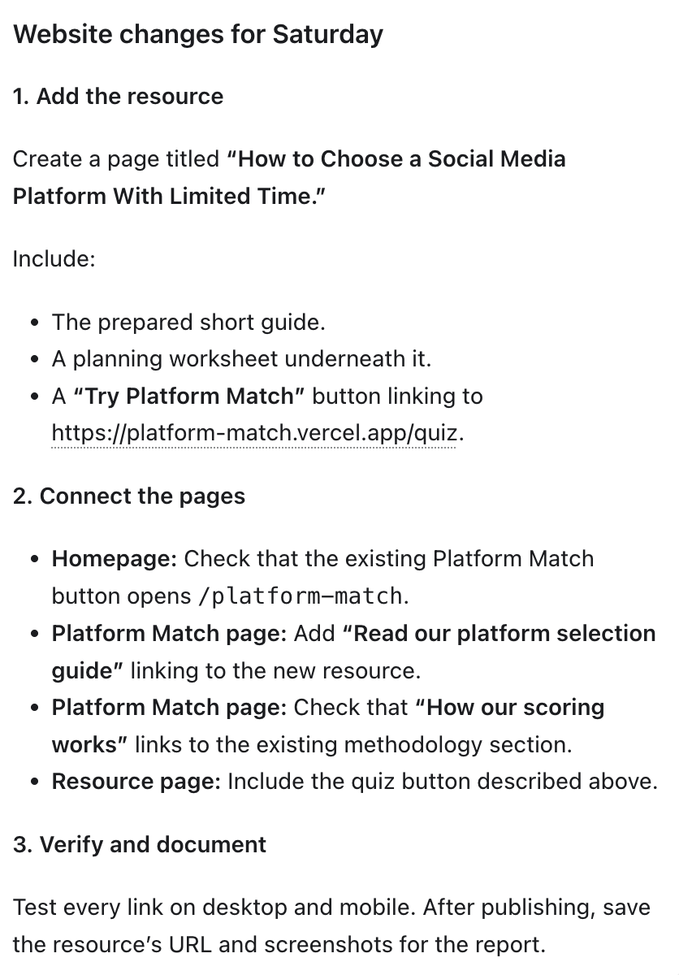
- Content for AI: We included a introduction page , an FAQ page with 5 relevant and potentially most asked questions, and a six-factor scoring table explaining how Platform Match weights its six factors when recommending social media platforms, and 2 other articles that go under the umbrella of our keyword and website goal to give additional value to website visitors. We also added a worked example.
- Article 1

How Your Goals Help You Choose the Best Social Media Platform for Business
The best social media platform for business depends on what you want to achieve. Before choosing a channel, identify your audience, the action you want them to take, and the content your team can consistently create.
A clear goal helps you compare platforms with a purpose.

Start with one business goal
Your business may want more visibility, website visitors, sales, and customer conversations. For your initial plan, choose one main priority.
A bakery introducing a new menu might focus on awareness. A consultant with appointment availability might focus on inquiries. These are different goals, so the content, call to action, and measures of progress should reflect that difference.
Use this table to connect your goal to a practical action:
Your goal | What you want people to do | What you could track
Brand awareness | Discover and explore your business | Relevant reach and profile visits
Website traffic | Visit a useful page | Visits arriving from your social content
Inquiries | Ask about your product or service | Relevant messages and information requests
Sales | Complete a purchase | Purchases attributable to social activity, where tracking allows
Community | Participate in useful conversations | Relevant comments and repeat participation
Choose measures you can actually observe. Likes can provide feedback, but they do not automatically show whether your business goal was achieved.

Check where your audience looks for information
Consider how your customers discover businesses like yours and what helps them make decisions. Ask customers directly, review existing analytics, or examine relevant audience research.
Avoid choosing a platform only because it is popular. The important question is whether it offers a useful way to reach and communicate with your intended customers.

Match the plan to your content strengths
List what your team can produce well: photographs, short videos, detailed demonstrations, written explanations, or graphics.
Then consider the time needed to create that content and respond to people. A plan that fits your team’s skills and capacity is easier to maintain and evaluate.

Compare your options with Platform Match
Platform Match compares Instagram, TikTok, Facebook, LinkedIn, YouTube, and Pinterest using six factors:
- Target audience
- Marketing goal
- Industry
- Content strengths
- Brand voice
- Available time
Use the recommendation alongside your customer knowledge to choose an initial channel priority. Compatibility scores are planning indicators, not predictions of sales or engagement.
Try the free Platform Match quiz and explore which platform fits your business inputs.
By the Platform Match student project team.
—---article 2

Choosing the Best Social Media Platform for Business With Limited Time
Choosing the best social media platform for business also means choosing a workload your team can manage. If you have only a few hours each week, consider how much time you can spend creating content, publishing, responding, and reviewing results.
Start with a manageable channel priority before expanding your activity.

Work out your actual weekly capacity
Look at the time available alongside your other responsibilities. Include the less visible tasks, such as checking links, answering questions, and reviewing what happened after publication.
For a team with three hours available each week, this example provides a starting point:
Activity | Weekly time | What to do
Plan | 30 minutes | Choose a useful topic and the audience action you want
Create | 60 minutes | Produce content that fits your strongest format
Prepare to publish | 30 minutes | Write captions, check details, and prepare posts
Respond | 45 minutes | Spread time across the week for comments and messages
Review | 15 minutes | Record the outcome and choose one adjustment
Total | 180 minutes | Three hours across the week
This is a sample schedule to adapt. The amount of content you can produce will depend on its complexity and your team’s skills.

Build around one useful topic
Choose a topic that answers a customer question or helps people understand your offer.
For example, a bakery could photograph one product and use the material for a product introduction and a short explanation of how it is made. A service business could turn one customer question into a written answer and a simple checklist.
The aim is to make useful material within your time budget, rather than commit to more posts than you can finish.

Consider the extra work before adding a platform
Some material may be suitable for another channel after adaptation. Before expanding, account for the additional editing, captions, publishing, and responses.
If the extra channel pushes you beyond your available time, simplify the plan or keep your focus on the initial priority.

Review both the outcome and the workload
Ask two questions:
- Did the content encourage the action we wanted?
- Could we maintain the plan within our available time?
Track an outcome connected to your goal, such as relevant inquiries or visits to a useful website page. If production repeatedly takes too long, reduce the workload or simplify the format.

Include your capacity in your platform decision
Platform Match considers available time alongside audience, goals, industry, content strengths, and brand voice. In the quiz, a three-hour weekly budget falls within the “2 to 5 hours per week” option.
Take the free Platform Match quiz to compare six platforms using your business’s goals and available capacity.
By the Platform Match student project team.
—----
Intro text:

Find the Best Social Media Platform for Your Business
The best social media platform for business depends on your audience, goals, content strengths, and available time. Platform Match helps you compare your options and decide where to focus your effort.
Our free quiz compares Instagram, TikTok, Facebook, LinkedIn, YouTube, and Pinterest using six factors: target audience, marketing goal, industry, content strengths, brand voice, and weekly capacity.
Answer six questions to receive platform recommendations and a suggested content roadmap. Use the results as a starting point for a plan you can test and adapt.
Find your platform match — start the free quiz.
Platform Match is a student-created project for MAR649.
—-- FAQ

Frequently Asked Questions About Platform Match

1. What is the best social media platform for my business?
There is no single best platform for every business. Your choice should reflect where your intended customers spend time, what you want to achieve, and the content your team can consistently create.
Platform Match helps you compare six networks using your business inputs, giving you a starting point for deciding which channel to prioritize.

2. What is Platform Match, and is it free?
Platform Match is a free social media platform selection tool created as a MAR649 student project. It compares Instagram, TikTok, Facebook, LinkedIn, YouTube, and Pinterest.
Complete the six-question quiz to view your compatibility rankings and a suggested content roadmap.

3. How does Platform Match calculate its recommendations?
The published framework uses six weighted factors:
- Target audience: 30%
- Marketing goal: 25%
- Industry: 15%
- Content strengths: 15%
- Brand voice: 10%
- Available time: 5%
Your selected answers shape the comparison. These weights describe the importance of each factor within the project’s framework.

4. Can I use Platform Match if I have little time for social media?
Yes. The quiz asks how much time your team can dedicate each week, including an option for under two hours.
Choose the answer that reflects your actual capacity, including content creation, publishing, and responses. Review the recommendation and begin with a workload you can maintain.

5. Does a high compatibility score guarantee results?
No. A compatibility score indicates fit within Platform Match’s framework. For example, a score of 94% does not mean a 94% chance of success.
Results depend on your audience, offer, content, execution, and other factors. Use the recommendation as a planning aid, then adjust your approach using actual outcomes.
Ready to compare your options? Take the free Platform Match quiz.
Created by the Platform Match student project team for MAR649.

- E-E-A-T: Prepared a “About Us” and “Why Work With Us” page. Outlined team information and a fictional bakery demonstration; actual quiz output still needs to be added.
- 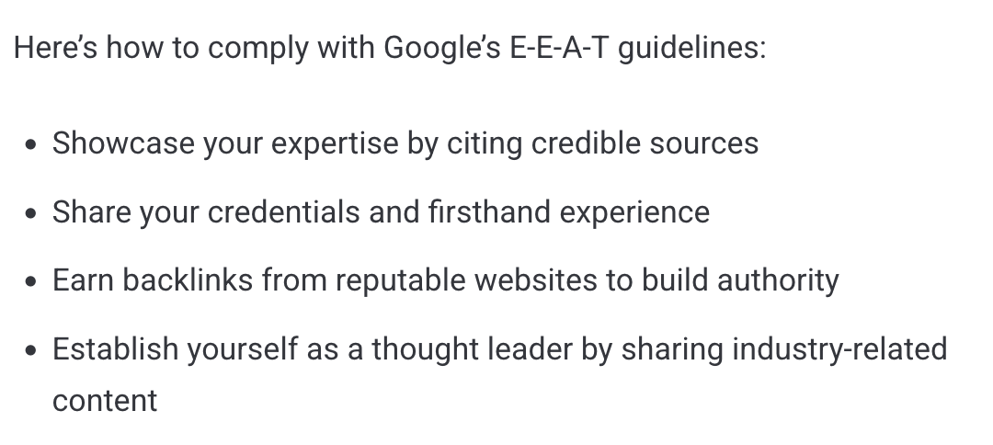!!!!

About Us
Pace Marketing Lab is a student-created digital marketing concept developed for MAR649. Through our Platform Match tool, we explore how small businesses and nonprofits can make clearer decisions about their social media priorities.
We created Platform Match to help visitors compare six social media platforms using their audience, marketing goals, industry, content strengths, brand voice, and available time.
Our approach combines a public decision framework with practical educational content, including guides, FAQs, and worked examples. Visitors can explore the methodology and try the free quiz to understand how their inputs influence the recommendations.

Meet the Project Team
Our team brings together students working on keyword research, website development, content, off-site SEO, and answer engine optimization.
[Add each member’s real name, project role, and one sentence describing their contribution.]

About This Project
Pace Marketing Lab and Platform Match are academic project concepts. Business scenarios are illustrative unless explicitly identified as real research. Recommendations provide a starting point for planning and testing; they do not represent proven client outcomes.
Explore Platform Match.
—-

Why Work With Us
Our project focuses on helping small businesses make social media decisions they can understand and put into practice.

Understand the Recommendation
Platform Match publishes the six factors and weights used in its decision framework. You can review the methodology alongside your results to understand the considerations behind the comparison.

Plan Around Your Resources
The quiz considers your content strengths and available weekly time alongside your audience and goals. This helps you explore channel priorities that reflect your team’s circumstances.

Turn Information Into a Starting Plan
Our guides, FAQs, and worked examples explain how to approach platform selection. The quiz connects your selected inputs to platform rankings and a suggested content roadmap.

Explore Before Making a Commitment
The current tool is free to use. You can try the quiz, review the framework, and decide which recommendations are worth testing against your own customer knowledge.
Try the free Platform Match quiz.

- Topical authority (applying the keyword in these articles) : We prepared a platform-selection guide, planning worksheet, and two supporting articles addressing business goals and time constraints. Together with the FAQs and worked example, these provide related information around our main topic. Internal links connect the resources to Platform Match. -looking at keyword strategy, tab in semrush - And the following sub keyword: social media content creation - blog tab, having a article about small business and social media, linking other articles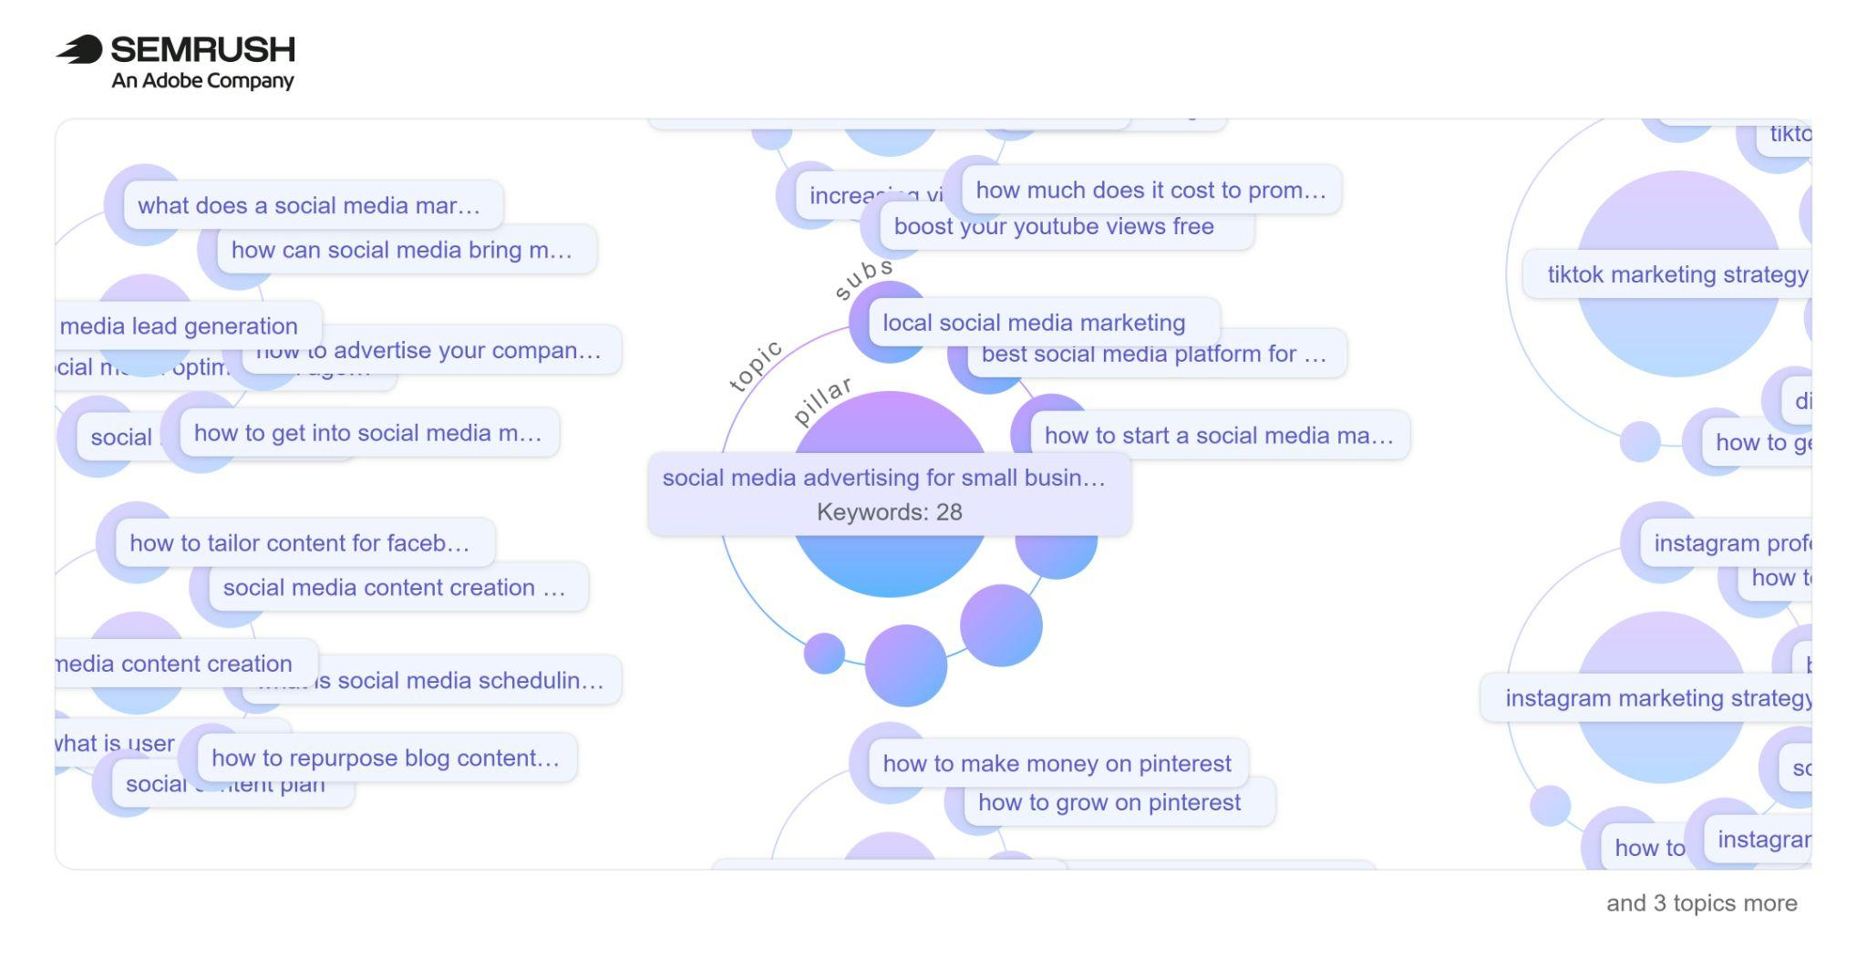
- Mentions and sentiment: We created an Instagram presence and prepared educational posts explaining Platform Match. We also drafted a simulated blogger pitch to seek relevant external coverage. For a real launch, we would invite honest feedback from users who have tried the tool. Independent coverage and user sentiment have not yet been measured.

5) Technical SEO (not required)

Link to our webpage:

A website that stands out from the crowd.

